BRICS STI Framework Programme
Coordinated call for BRICS multilateral projects – 5th Call 2021

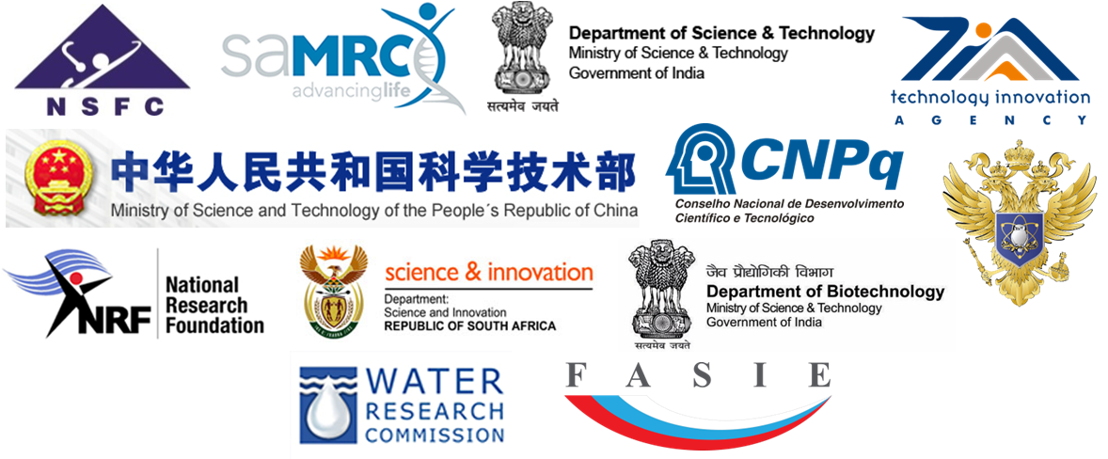

1. Thematic area
☐ Transient astronomical events and Deep Survey science | ☐ Materials science and nanotechnology for addressing environmental, climate change, agricultural, food and energy issues
☐ Antimicrobial resistance: technologies for diagnosis and treatment | ☐ Renewable energy, including smart grid integration
☐ Simulation and big data analytics for advanced precision medicine and public healthcare | ☐ Ocean and polar science and technology
☐ HPC and BigData for Sustainable Development: Solving Large Scale Ecological, Climate and Pollution problems | ☐ Water treatment technology
☐ Innovation and entrepreneurship on Photonic, Nanophotonics and metamaterials for addressing bio-medicine, agriculture, food industry and energy harvesting issues | ☐ Research in aeronautics and aerospace

2. Title of Collaborative Research Project
Full title/Working title:
Acronym (max 10 characters):

3. Proposed duration of the Collaborative Research Project
☐2 years | ☐3 years

4. Project summary (Maximum 2100 characters including spaces)
Keywords
Abstract (main contents of research including different roles to be played by each research team)

5. Objectives (maximum 10000 characters including spaces)
Please state the general nature, context and specific purpose of the research collaboration, with a summary at the beginning and with references, where necessary, to academic literature. Details should be articulated clearly, particularly regarding the following points:
1. Scientific/Intellectual Merit
* Scientific quality and innovativeness of the goals and objectives of the joint research plan
2. Fit to call objectives
* Addressing at least one of the call topics
* Expected impacts (e.g. scientific, economic, social etc.)
3. Personnel/Expertise of the Consortium
* Competence and expertise of teams and complementarities of consortium
* Added value to be expected from the international research collaboration, balanced cooperation

6. Research Teams
The research team of the “Lead PI (coordinator)” should be indicated as the “1st country” (if 4th or 5th country joins, please create additional table).

(1st country name) Researchers in Research Team /project coordinator/
Name of Lead PI | Gender | Title (Prof, Dr, etc) | Qualifications | Organization | Division
(Researchers)
Most recent relevant publications (up to 5 publications)

(2nd country name)Researchers in Research Team
Name of Lead PI | Gender | Title (Prof, Dr, etc) | Qualifications | Organization | Division
(Researchers)
Most recent relevant publications (up to 5 publications)

(3rd country name)Researchers in Research Team
Name of Lead PI | Gender | Title (Prof, Dr, etc) | Qualifications | Organization | Division
(Researchers)
Most recent relevant publications (up to 5 publications)

7. Budget plan

(Please indicate only “Requested budget” and consult with your own country’s funding organization(s) regarding eligible expenses as budgetary rules differ from country to country. See also national annexes for additional information (if 4thor 5th country joins, please create additional lines in a table below)
 | Funding requested for 1st year | Funding requested for 2nd year | Funding requested for 3rd year | Total funding in local currency for the full duration of the project | National funding organization to request funds from
(1stcountryname) |  |  |  |  | Выберите элемент.
(2ndcountryname) |  |  |  |  | Выберите элемент.
(3rdcountryname) |  |  |  |  | Выберите элемент.

